**BOWLING GREEN SPRINT TRIATHLON**

**Make Checks Payable to:**

**Bowling Green**

**Sprint Triathlon**

**c/o Graves Gilbert Clinic**

**Human Resource Dept**

**P. O. Box 90007**

**Bowling Green, KY 42102-9007**

***or pay on-line at:***

***www.raceroster.*com**

**2018 Entry Form---Race date August 26th**

 Athena Class  Clydesdale Class

Female 165lbs + Males 220+

**STEP 1: Race Category**

(check **ONE** category only.)

Individual USAT member

Relay- (circle one)

Male Female Mixed

Individual USAT non-member

**Team name :** _______________________

**STEP 2: Participant Information**

First Name_____________________________

Last Name__________________________________________________

**Age on Dec. 31,**

**2018**

/

/

**Date of Birth**

Female

Male

Gender

Mailing Address

City____________________________________________________________

Zip

State

2X

XL

L

M

S

Shirt Size

**USAT #**

E-mail Address____________________________________________________________________

Other Phone

-

-

-

-

Home Phone

Emergency Contact__________________________________________________________________________________

See our website at <http://triathlon.ggclinic.com> for help in estimating swim times

**Relay Team Name**

-

-

Emergency Phone

**Estimated swim time**

**seconds**

**minutes**

**STEP 4: Payment**

**STEP 3: Choose Race**

**Make Checks Payable to:**

**Bowling Green**

**Sprint Triathlon**

**c/o Graves Gilbert Clinic**

**Human Resource Dept**

**P. O. Box 90007**

**Bowling Green, KY 42102-9007**

$60 on or before July 26, $65 after July 26,

and $70 after August 12th

**\*Important\***

ALL RELAY

TEAMS

$15 refund for each USAT member on relay team

**Individual USAT member**

$75 on or before July 26, $80 after July 26,

and $85 after August 12.

**Individual non-USAT member**

$110 on or before July 26, $115 after July 26,

and $120 after August 12.— $15 refund per USAT card

**Relay**

**List names of additional relay members below (include USAT numbers where applicable). Each non-USAT member is charged an additional $15 for a one-day USAT license.**

First Name__________________________________________

Last Name_____________________________________________

**USAT #**

/

/

**Date of Birth**

Female

Male

Gender

**Age on Dec. 31,**

**2018**

2X

XL

L

M

S

Shirt Size

How did you first hear about the Bowling Green Sprint Triathlon?

Poster/Flyer  Internet  Radio/TV  Tri Finder website  Friend or Coach 

**USAT #**

Shirt Size

Female

Male

/

/

**Date of Birth**

Gender

**Age on Dec. 31,**

**2018**

S

M

L

XL

2X

First Name______________________________________

Last Name_____________________________________________

**STEP 5:**

**Total**

**Payment**

**WARNING: READ CAREFULLY. THIS AGREEMENT INCLUDES A RELEASE OF LIABILITY AND WAIVER OF LEGAL RIGHTS AND DEPRIVES YOU OF THE RIGHT TO SUE USA TRIATHLON AND OTHER PARTIES. DO NOT SIGN THIS AGREEMENT UNLESS YOU HAVE READ IT IN ITS ENTIRETY. SEEK THE ADVICE OF LEGAL COUNSEL IF YOU ARE UNSURE OF ITS EFFECT.**

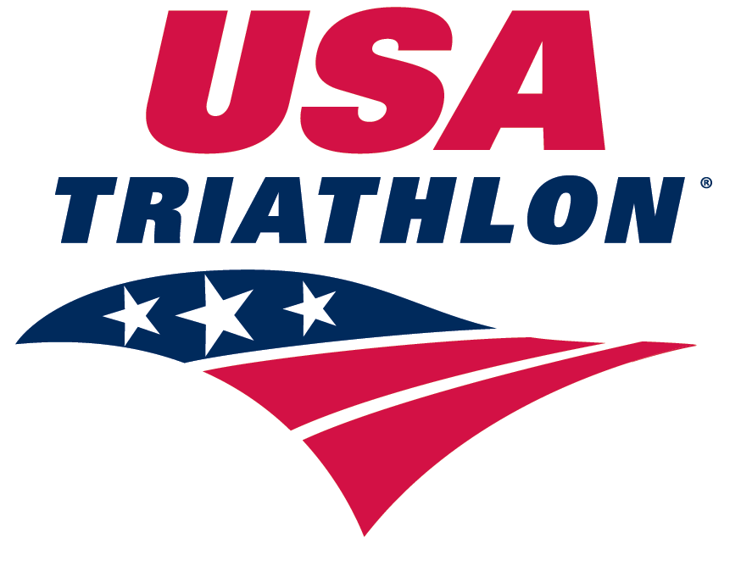

**WAIVER AND RELEASE OF LIABILITY,  
ASSUMPTION OF RISK AND INDEMNITY AGREEMENT**

IN CONSIDERATION of USA Triathlon (“**USAT**”) allowing me to participate in any USAT sanctioned event (**the “Event” or “Events”**) as either a member of USAT or through the issuance of a single event license or permit; I, for myself, and on behalf of my spouse, children, parents, guardians, heirs and next of kin, and any legal and personal representatives, executors, administrators, successors and assigns, hereby agree to and make the following contractual representations pursuant to this Waiver and Release of Liability, Assumption of Risk and Indemnity Agreement (**the “Agreement”**).

1. I hereby represent that (i) I am in good health and in proper physical condition to participate in the Event; and (ii) I am not under the influence of alcohol or any illicit or prescription drugs which would in any way impair my ability to safely participate in the Event. I agree that it is my sole responsibility to determine whether I am sufficiently fit and healthy enough to participate in the Event.
2. I understand and acknowledge the physical and mental rigors associated with triathlon, duathlon, or other multi-sport events, and realize that running, bicycling, swimming and other portions of such Events are inherently dangerous and represent an extreme test of a person’s physical and mental limits. I understand that participation involves risks and dangers which include, without limitation, the potential for serious bodily injury, sickness and disease, permanent disability, paralysis and loss of life; loss of or damage to equipment/property; exposure to extreme conditions and circumstances; accidents, contact or collision with other participants, spectators, vehicles or other natural or manmade objects; dangers arising from adverse weather conditions; imperfect course conditions; water, road and surface hazards; equipment failure; inadequate safety measures; participants of varying skill levels; situations beyond the immediate control of the Event Organizers; and other undefined risks and dangers which may not be readily foreseeable or are presently unknown (“Risks”). I understand that these Risks may be caused in whole or in part by my own actions or inactions, the actions or inactions of others participating in the Event, or the acts, inaction or negligence of the Released Parties defined below, and I hereby expressly assume all such Risks and responsibility for any damages, liabilities, losses or expenses which I incur as a result of my participation in the Event.
3. I agree to be familiar with and to abide by the Rules and Regulations established for the Event, including but not limited to the Competitive Rules adopted by USAT and the Guide to Prohibited Substances and Prohibited Methods of Doping adopted by the United States Anti- Doping Agency. I also accept sole responsibility for my own conduct and actions while participating in the Event, and the condition and adequacy of my equipment.
4. I hereby Release, Waive and Covenant Not to Sue, and further agree to Indemnify, Defend and Hold Harmless the following parties: USAT, the Event Owners, Organizers and Promoters, Race Directors, other participants in the sanctioned event, Sponsors, Advertisers, Host Cities, United States Olympic Committee (USOC), Local Organizing Committees, Venues and Property Owners upon which the Event takes place, Law Enforcement Agencies and other Public Entities providing support for the Event, and each of their respective parent, subsidiary and affiliated companies, officers, directors, partners, shareholders, members, agents, employees and volunteers (**Individually and Collectively, the “Released Parties” or “Event Organizers”**), with respect to any liability, claim(s), demand(s), cause(s) of action, damage(s), loss or expense (including court costs and reasonable attorneys fees) of any kind or nature **(“Liability”**) which may arise out of, result from, or relate to my participation in the Event, including claims for Liability caused in whole or in part by the negligence of the Released Parties. I further agree that if, despite this Agreement, I, or anyone on my behalf, makes a claim for Liability against any of the Released Parties, I will indemnify, defend and hold harmless each of the Released Parties from any such Liability which any may be incurred as the result of such claim.
5. All matters contained within this waiver shall be governed by and construed in accordance with the substantive laws of the State of Colorado.

I hereby warrant that I have read this Agreement carefully, understand its terms and conditions, acknowledge that I will be giving up substantial legal rights by signing it (including the rights of the minor, my spouse, children, parents, guardians, heirs and next of kin, and any legal and personal representatives, executors, administrators, successors and assigns), acknowledge that I have signed this Agreement freely and voluntarily, without any inducement, assurance or guarantee, and intend for my signature to serve as confirmation of my complete and unconditional acceptance of the terms, conditions and provisions of this Agreement. This Agreement represents the complete understanding between the parties regarding these issues and no oral representations, statements or inducements have been made apart from this Agreement. If any provision of this Agreement is held to be unlawful, void, or for any reason unenforceable, then that provision shall be deemed severable from this Agreement and shall not affect the validity and enforceability of any remaining provisions.

**Parental Consent (required if the participant is less than 18 years of age)**

As the Parent and/or Legal Guardian to the minor identified above, I hereby accept and agree to all of the terms and conditions of this Agreement on behalf of the minor in connection with the minor’s participation in the Event(s). If, despite this Agreement, I, or anyone on the minor’s behalf, makes a claim for Liability against any of the Released Parties, I will indemnify, defend and hold harmless each of the Released Parties from any such Liabilities which any may be incurred as the result of such claim.

Signature_________________________________________________________ Date__________________